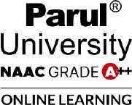


PARUL UNIVERSITY

Centre for Distance and Online Education List of Support Staff

- Administrative Staff:

Sr. No. | Staff Name | Designation
1 | Dr. Pawan Dwivedi | Deputy Registrar
2 | Mr. Sachin Patel | Assistant Registrar
3 | Ms. Akanksha Dave | Section Officer
4 | Ms. Ashwini Rajwade | Assistants
5 | Ms. Renu Yadav | Assistants
6 | Mr. Kayur Babhaniya | Computer Operators
7 | Mr. Yash Desai | Computer Operators
8 | Ms. Vaishaliben Darji | Multi-Tasking Staff
9 | Ms. Chitranshi Varma | Multi-Tasking Staff

